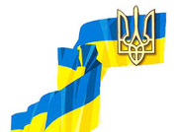

National Academy of Science of Ukraine

NATIONAL ANNUAL REPORT
UKRAINE

The state of biological communities of the Ukrainian sector of ecosystem of the Black Sea in 2021/2022 years

Complied: Dr. Biol. Sc. Galyna Minicheva
Institute of Marine Biology NAS Ukraine

October, 2022

Reporting organizations:

    - Institute of Marine Biology NAS Ukraine (IMB)

Authors of the National Report:

Chapter | Authors
INTRODUCTION | Dr. Biol. Sc. Minicheva G.
MILITARY IMPACT | Dr. Biol. Sc. Minicheva G.,  Dr. Sokolov E.,  Dr. Kalashnik E.,  Dr. Bolshakov V.,  Marinets A.,  Martunuk M.,  Kurakin A.
INVASION SPECIES | Dr. Biol. Sc. Son M.,  Dr. Biol. Sc. Kvach Yu.
PROTECTION AND RESTORATION OF ANIMAL SPECIES LISTED IN THE RED BOOK OF UKRAINE | Dr. Biol. Sc. Son M.,

INTRODUCTION
The Ukrainian sector of the Black Sea is characterized by special geographical conditions associated with the presence of the shelf platform and the flow of three large European rivers - the Danube, the Dniester and the Dnieper. In this regard, in this region, the structural-functional organization of the biological component and the ecological status largely depend on the influence of such climatic factors as river runoff, which depends on the amount of precipitation and sea water temperature. Therefore, the assessment of the state of biological diversity and the Ecological Status Class (ESC) of the Ukrainian sector of the Black Sea must be carried out taking into account the assessment of these weather conditions of the year.
In addition to the background state of weather conditions, the biotic component is influenced by various anthropogenic influences. If in 2021 there was a standard average regional level of impact on the marine environment, then 2022 has become unprecedented, for the Black Sea marine ecosystem. After the attack on Ukraine by the russian federation on February 24, 2022, the hot phase of the war began, which had a massive impact on maritime facilities and the possibility of marine investigation. The mined coast and military activity practically stopped expedition work in 2022. The main information about the state of the sea surface and oil spills was obtained using remote observation methods, satellite data from the Santinel 1. Also, in the warm period of the year (mid-September), using only light diving equipment, in the coastal zone, a comprehensive hydro biological survey was carried out at the long-term monitoring site which located in the zone of Odessa city beaches. These data served as material for a preliminary assessment and comparison of the state of the ecological state of the marine ecosystem in 2022 with the previous period and were included in this report.

MILITARY IMPACT

As the sad experience of military impact on the Black Sea marine ecosystem (since February 2022) has shown, this type of anthropogenic threats have 2 objective components:
1 - Negative, associated with direct military operations in the sea area (Alteririan and rocket fire, crash of ships and aircraft, mining of water areas, etc.)
2 - Positive, associated with an unprecedented decrease in the intensity of anthropogenic impacts in peacetime (fishing, ship traffic, recreational load, construction in the coastline, etc.).
Possible consequences of negative impact:
- spills of oil products in large areas, including protected ones;
- accumulation of heavy metals in aquatic organisms, including lead (Pu), which is included in large quantities in military equipment;
- transfer of chemical contaminants through food webs from areas of military operations to adjacent water areas;
- hydroacoustic impact, causing injury to hydrobionts and, first of all, to such highly organized ones as dolphins;
- termination of the MRAs protection regime;
- uncontrolled fires in the adjacent coastal zone and washout of combustion products and other hazardous chemicals from active hostilities into the coastal zone;
- non-observance by military water transport of the rules for the exchange of ballast water, which can lead to the outbreak of invasive species;
- the coverage of large transboundary territories with negative consequences due to the hydrodynamic properties of the aquatic environment, which carries matter and energy over long distances.
Possible consequences of a positive impact:
-the unprecedented experiment of depopulation of a long coastline (mining and prohibition of military authorities) which allows restoring the life cycles and natural behaviour of a large number of aquatic organisms, as well as inhabitants associated with the coastal zone (seabirds, invertebrates, vegetation);
- stop fish industrial and recreational underwater fishing;
- significant decrease in the movement of commercial vehicles;
- stop underwater hydrotechnical works, including dumping in navigable channels.

Example of negative impact
During February-October 2022, there were many incidents related to military aggressionn, the areas of all three Marine Protected Arias (MPA) were covered with oil products many times, almost up to 100%, because of the destruction of naval ships and the destruction of military aircraft (Figure 1.). At the national level, information was collected on the areas of oil spills at the MPAs using satellite technology. This information was officially transfer by the Institute of Marine Biology of the National Academy of Sciences of Ukraine to the Operational Headquarters under the State Ecological Inspection of Ukraine. The availability of such information will allow, analysing the consequences of the military impact on the biological of
the MPAs and determine possible ways of intensive recovery.

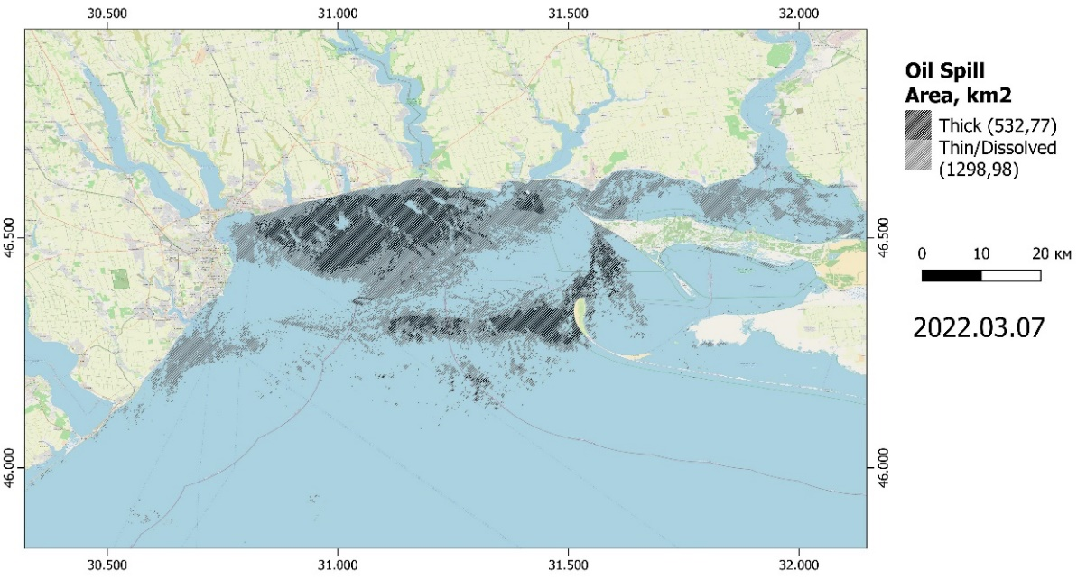 a

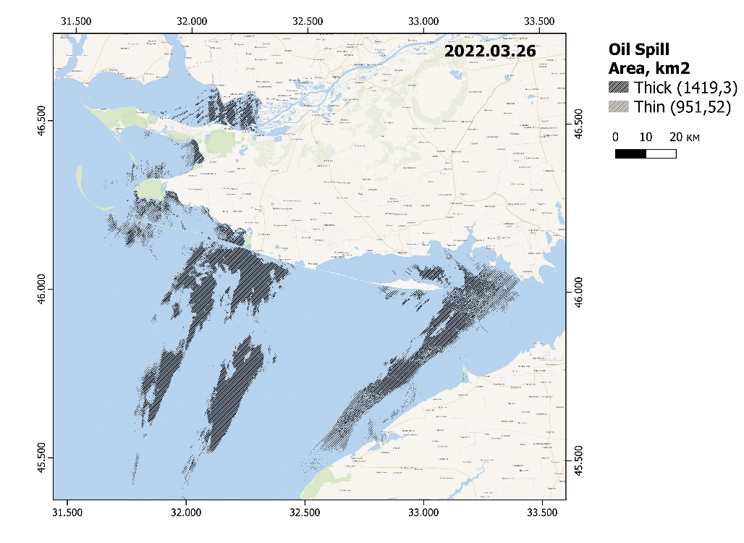 b
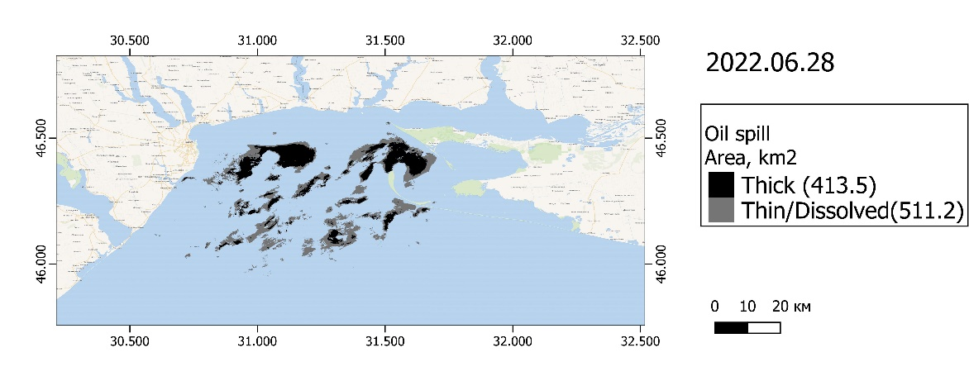c
Figure 1. Examples of covering the Ukrainian water areas including the water areas of the MPAs with oil products as a result of military actions: National Natural Park Biloberezhia Sviatoslava (a); Сhornomorsky Biosphere Reserve (b); Nationally Important Reserve (botanical ) Zernov’s Phyllophora Field (c)

Example of positive impact
Climatic background
To assess the biological component, information on anomalous deviations of the climatic factor for the weather conditions of the year is important. It is generally accepted that if the average annual deviation of river runoff, temperature or other abiotic factors is less than 10%, compared with the long-term average regional value, then this is a year with normal abiotic conditions. 2021 may be an example of normal weather conditions typical of the region - + 4% water temperature and – 6% river flow (Figure 2).
a

b
Figure 2. Long-term anomalies of temperature of sea water (a) and Danube river runoff (b) for the north-western part of the Black Sea (Ukrainian sector)

Estimated for the first half of 2022 - the 2.5 times less precipitation was observed compared to the long-term regional level and not high water temperatures. The average temperature was 8.3 C◦, which allows us to attribute 2022 to cool periods. This combination of climatic conditions contributes to the natural increase in ecological status. Thus, the conditions of an abnormally dry and cool year influenced the decrease in the intensity of the primary production process and the improvement of the ESC. Based on the morphofunctional indicator of phytobenthos - the Surface Index for 2022, the lowest value was obtained - 6 units (Figure 3.). Thus, the prevailing climatic conditions under other negative military influences compensated for the situation and the marine environment was in good ecological conditions.

Figure 3. Long-term dynamics of the ESC of the Odessa coast, obtained on the basis of the morphofunctional indicator of phytobenthos - the Surface Index

In addition to favorable weather conditions in 2022, the positive components also include the complete removal of the recreational load on many kilometers of the coastline. Due to the danger of hostilities, the civilian population was not allowed to the coastal zone during the entire period. As a result of the removal of the anthropogenic load, the coastal zone has been transformed. Restorative plant succession began to occur on sandy beaches. Seabirds have gained free access to the coastal zone, as well as many hydrobionts that use the coastal zone in their life cycles (Figure 4).

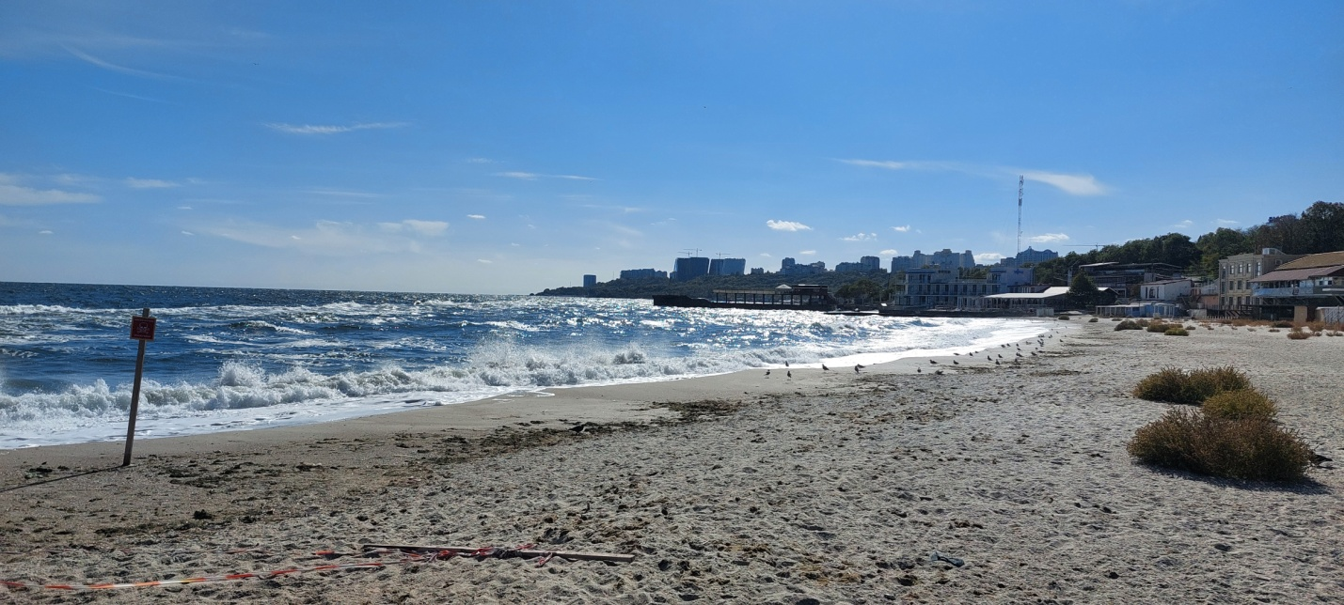
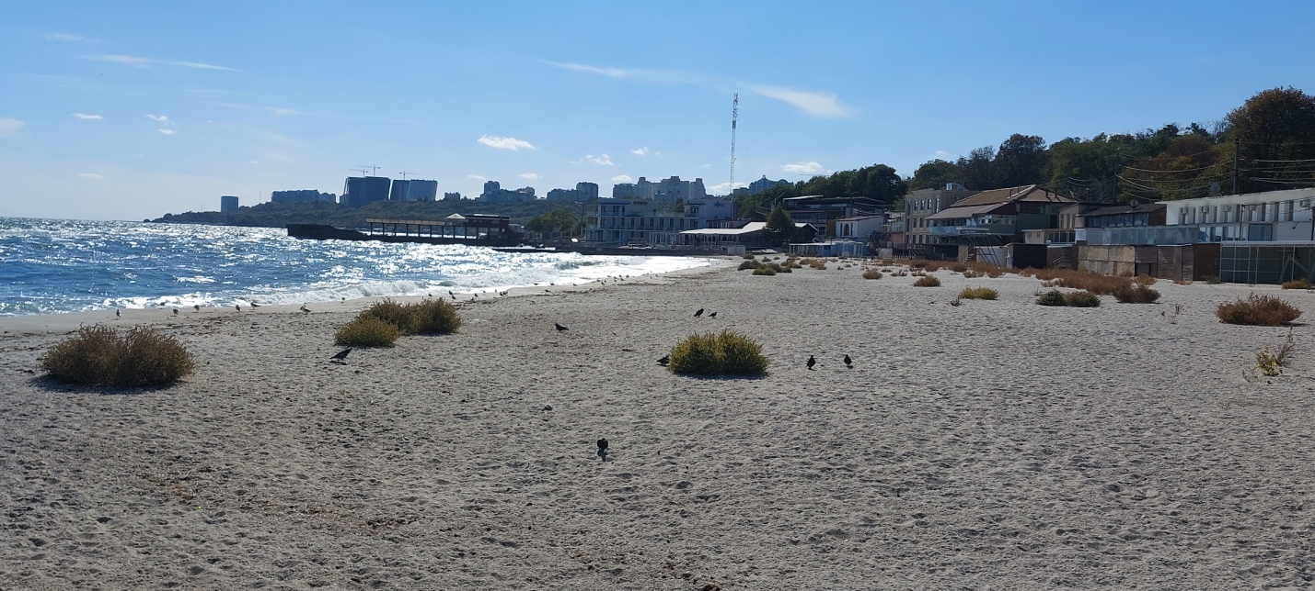
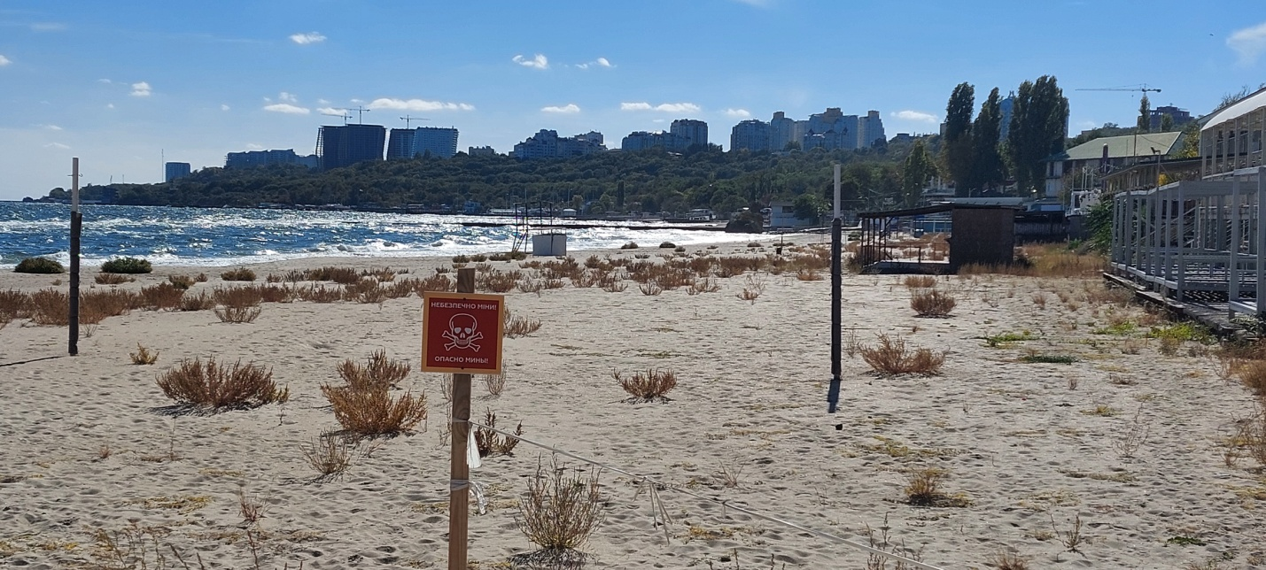
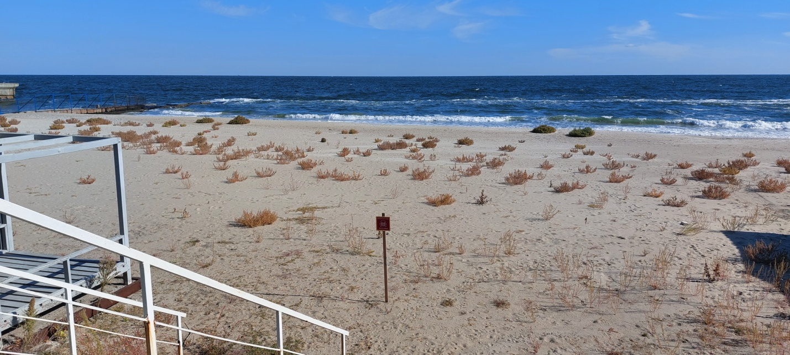
Figure 4. View of Odessa beaches in October 2022

Another confirmation that, despite the negative military impact, the ecological situation in general improved in 2022, is the long-term dynamics of the average specific surface area () of the floristic composition of macrophytes, which characterizes the ecological activity of autotrphs, compared to September. The figure 5 shows that in September 2022 the value of St is 40 units. was the lowest compared to previous years.

Figure 5. Decrease in the indicator of ecological activity of macrophytes (S/W_{x}) in 2022 on the Odessa coast for the period of October

Thus, it can be concluded that 2022 is the year of active hostilities, in addition to the negative impact, the consequences of which will need to be assessed, there was a general improvement in the environmental situation associated with favorable weather conditions and the complete absence of recreational load on the multi-kilometer coastal zone.
INVASION SPECIES
The invasive fish species, the pumpkinseed sunfish, Lepomis gibbosus (Actinopterygii: Centrarchidae), was studied in different localities in Ukraine during 2021 (Figure 6). This fish species has the North-American origin and currently widely spread almost in all territory of Europe, including of Ukraine.
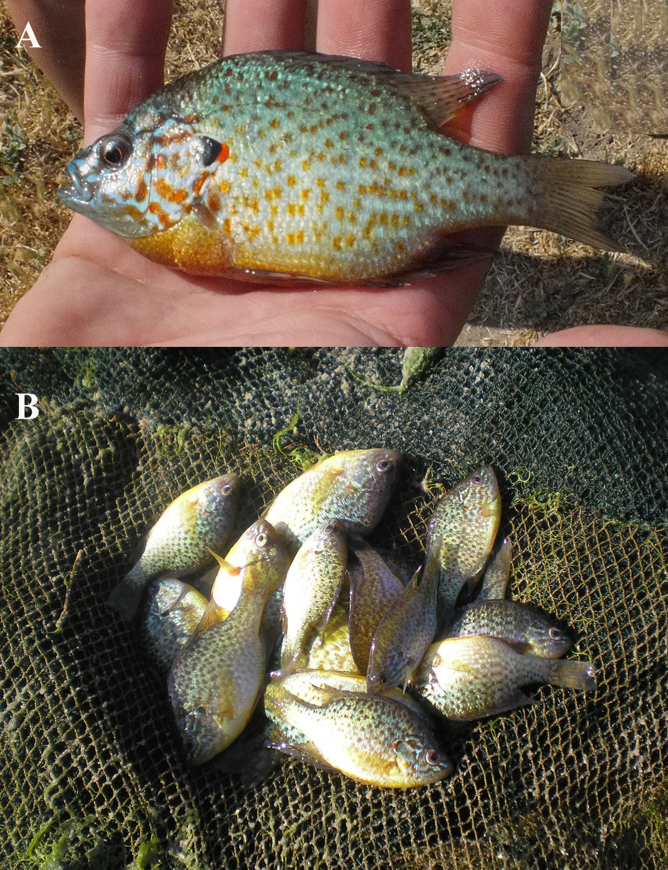
Figure 6. The pumpkinseed (Lepomis gibbosus) from the brackish water Khadzhibey Lyman (A) and Sukhyi Lyman (B), Ukraine

The fish was sampled in three freshwater localities (Lake Almazne, Lake Kartal, a canal of the Lower Dnieper irrigation system), also in two brackish water bodies: Sukhyi Lyman, with the salinity of 2.2‰, and the Khadzhibey Lyman, with the salinity of 5.0‰. The freshwater localities are related to the Lower Danube (Lake Kartal) and Dnieper basin: Lower Dnieper irrigation canal (Kherson Oblast) and Lake Almazne (City of Kyiv). All fish were studied for parasite presence, also a tissue sample (a fin) was collected for the DNA study from every dissected fish. In total, 97 fish individuals were studied; their size parameters are presented in Table 1.
Table 1. The number and size parameters of the pumpkinseed (Lepomis gibbosus) studied from different localities in Ukraine. n = fish number, SL = standard length (mm), TL = total length (mm).
Parameter |  | Lake Kartal | Sukhyi Lyman | Khadzhibey Lyman | Lower Dnieper | Lake Almazne
n |  | 19 | 16 | 20 | 21 | 21
SL | m±sd | 58.3±5.9 | 127.9±13.8 | 106.8±13.9 | 54.9±3.2 | 77.9±11.5
SL | min–max | 45–68 | 98–143 | 68–122 | 49–62 | 58–95
TL | m±sd | 71.9±6.8 | 150.4±15.0 | 126.0±16.5 | 68.1±4.2 | 77.0±11.5
TL | min–max | 55–84 | 119–170 | 80–144 | 60–76 | 63–107

We found that 6 different microsatellite loci with the allele richness 2-19 alley per locus are presented in Ukraine. The Lower Dnieper populations are characterised by maximal F-index (0.04), which indicates the high inbreeding. Among the 14 registered alleles the maximal richness is found in the Khadzhibey Lyman (6 alleles). The factor analysis of correspondence confirmed that all 5 populations form discrete clusters connected with each other, with Lake Kartal is most connected with the other bodies of water. The Ukrainian populations do not differ significantly from the other European populations, most closely related to populations from the basins of the Lower (Bulgaria) and the Middle Danube (Czech Republic).
There are 15 parasite species are registered in the pumpkinseed in Ukraine, including of two microparasites (a ciliate and a myxozoan), three monogeneans, four digeneans, two nematodes and crustaceans, one mite and one bivalve glochidium (Figure 7). The richest parasite fauna is registered in Lake Kartal (8 species) and the Sukhyi Lyman (6 species), less in the Lower Dnieper (4 species), and the minimal one is in the Khadzhibey Lyman and Lake Almazne (three species each).

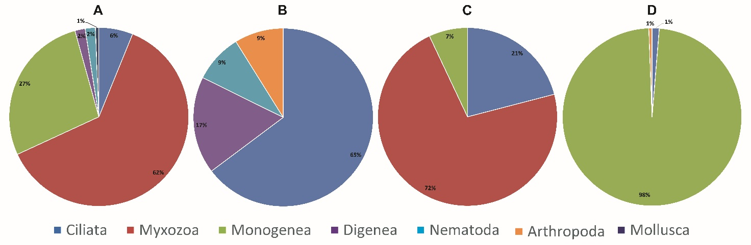
Figure 7. The parasite community composition of the pumpkinseed (Lepomis gibbosus) from four different localities in Ukraine. A = Lake Kartal, B = Sukhyi Lyman, C = Khadzhibey Lyman, D = Lower Dnieper. Lake Almazne is not presented because only digeneans are found

The parasite communities are represented manly by local European species, but also North-American and Asian ones were recorded. The fish from Lake Almazne (Kyiv) were infected obly with three European digenean species (Bucephalus polymorphus, Diplostomum pseudospathaceum and Tylodelphys clavata), all presented by larval stages. In the other studied water bodies both local and introduced parasites were found. Thus, three North-American parasite species, co-introduced with the pumpkinseed were registered, i.e. monogeneans Onchocleidus similis (Figure 8) and Onchocleidus dispar (Figure 9), and myxozoan Myxobolus dechtiari (Figure 10), which form 92% of abundance of all parasites found. But, the Asian copepods Neoergasilus japonicus and bivalve glochidia Sinanodonta woodiana, were registered sporadically.
The pumpkinseed parasite fauna composition differs by the water body in Ukraine (see Figure 7). The size of the studied fish does not affect the parasite community, thus did not used in the analysis (df = 1.6, χ² = 1.77, p = 0.183). The parasite abundance in the Lower Dnieper was significantly higher than ones from the other localities (GLM, p < 0.001). In the Khadzhibey Lyman it was significantly lower from all other water bodies, except of the brackish Sukhyi Lyman (GLM, p = 0.006, <0.001, 0.001 and 0.074 for Lake Almazne, Lower Dnieper, Lake Kartal and Sukhyi Lyman, correspondingly). In all localities, except of the Lower Dnieper, the fish free from parasites were registered. The parasite infracommunity (the parasite community in one host individual) comprised from 0 to 2 species in the Khadzhibey, and lakes Almazne and Kartal, but from 0 to 3 in the Sukhyi Lyman and Lower Dnieper. In the Sukhyi Lyman, the infracommunities were significantly richer, than in the other water bodies, except of the Lower Dnieper (GLM, P = 0.006, 0.016, 0.001 and 0.064 for Lake Almazne, Lake Kartal, Khadzhibey and Lower Dnieper, correspondingly).

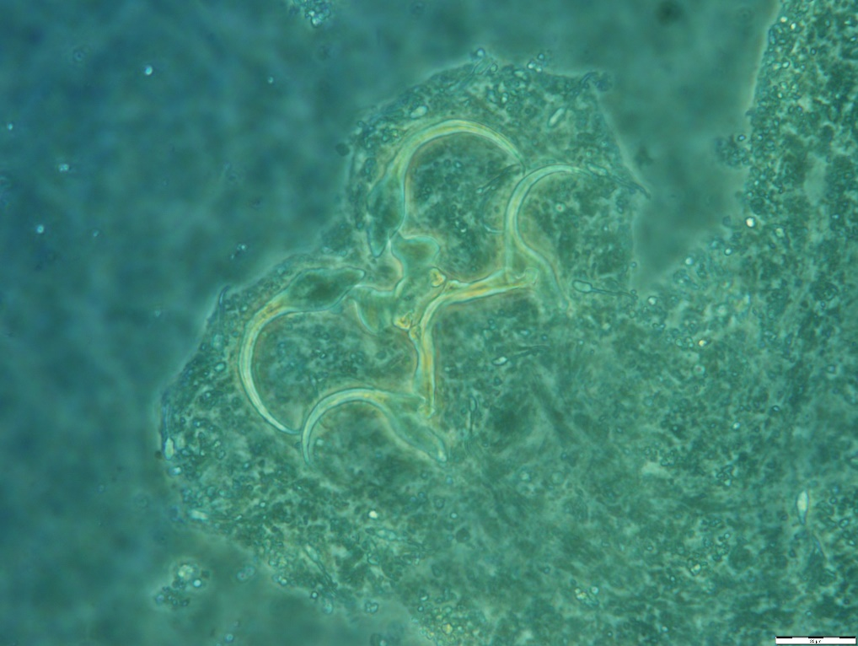
Figure 8. The haptor system of the introduced North-American monogeneans Onchocleidus similis from gills of the pumpkinseed (Lepomis gibbosus) from Ukraine
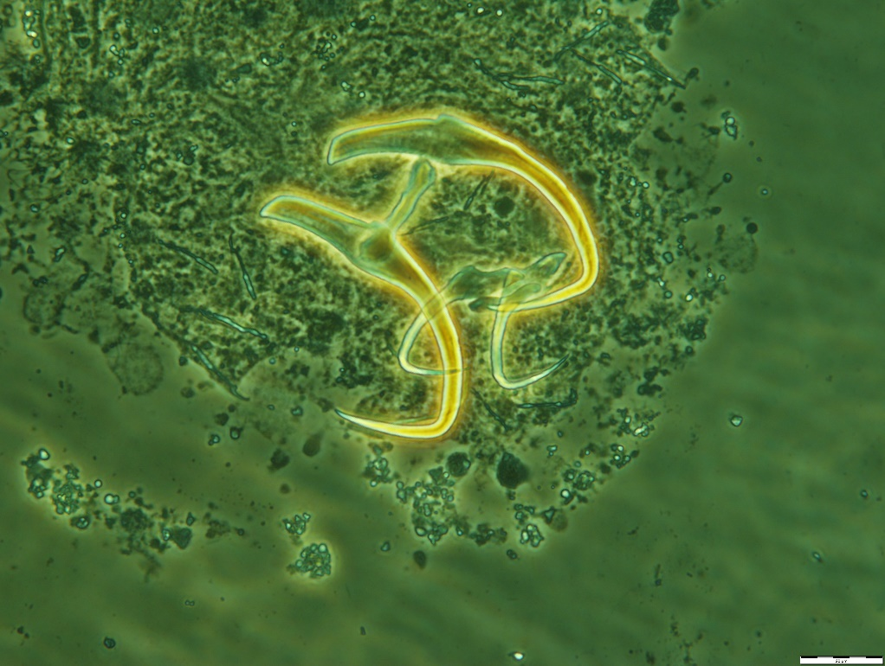
Figure 9. The haptor system of the introduced North-American monogeneans Onchocleidus dispar from gills of the pumpkinseed (Lepomis gibbosus) from Ukraine
Figure 10. The spores of the introduced North-American myxozoan Myxobolus dechtiari from muscles of the pumpkinseed (Lepomis gibbosus) from Ukraine
A species of hydromedusa Gonionemus cf. vertens (Figure 11), new to the Black Sea, was observed in the shallows of the Dzharylgach Bay during the summer of 2021.
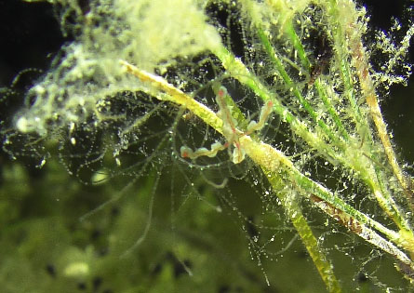
Figure 11. The hydromedusa Gonionemus cf. vertens, shallows of the Dzharylgach Bay (Photo of Alexander Kurakin)
New findings of alien species Macrobrachium nipponense and Pectinatella magnifica (Figure 12 ) were made in the waters of Buzunchuk Bay (Danube Delta) in October 2021.
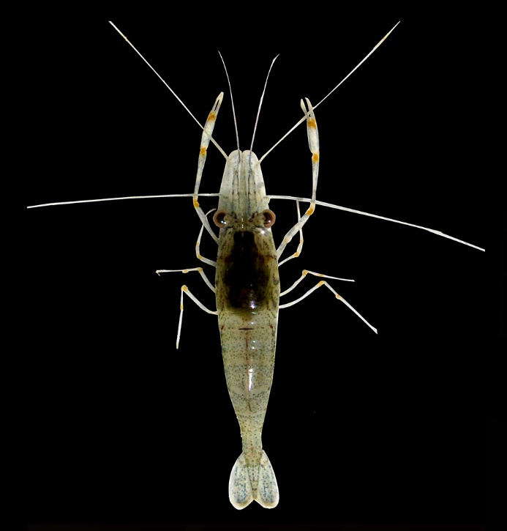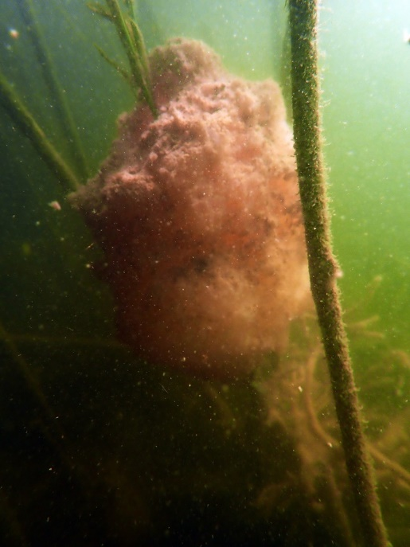
Figure 12. The prawn Macrobrachium nipponense and bryozoan Pectinatella magnifica, the Buzunchuk Bay in the Danube Delta (Photo of Mikhail Son)

In September 2021, the peacock blenny Salaria pavo (Figure 13), a rare species previously recorded off the coast of Crimea and Zmeinyi Island, was recorded entering the waters of the Sukhyi Liman.
Figure 13. Peacock blenny Salaria pavo, the Sukhyi Liman (Photo of Mikhail Son)
In October 2022, a new species for the Black Sea, the small crawling anemone Nematostella vectensis (Figure 14), originating from the coast of North America, was found in the littoral of the Sukhyi Liman (mud and mixed substrates)
Figure 14. Anemone Nematostella vectensis, the Sukhyi Liman (Photo of Alexander Koshelev)

PROTECTION AND RESTORATION OF ANIMAL SPECIES LISTED IN THE RED BOOK OF UKRAINE
Special studies of the status of Ponto-Caspian relict molluscan species listed in the Red Data Book in the lower reaches and estuaries of the Danube, Dniester, Southern Bug and Dnipro during August-October 2021 showed a gradual reduction in the habitat area of such species (in particular Euxinipyrgula lincta and Hypanis laeviuscula) (Figure 15) in the Dniester and Dnipro-Bug estuaries and the lower reaches of the Southern Bug. In the case of the Southern Bug, this is probably related to a sharp salinization due to the penetration of the sea water wedge. Mass population of Euxinipyrgula lincta was recorded in the Konka branch of the Dnipro delta.
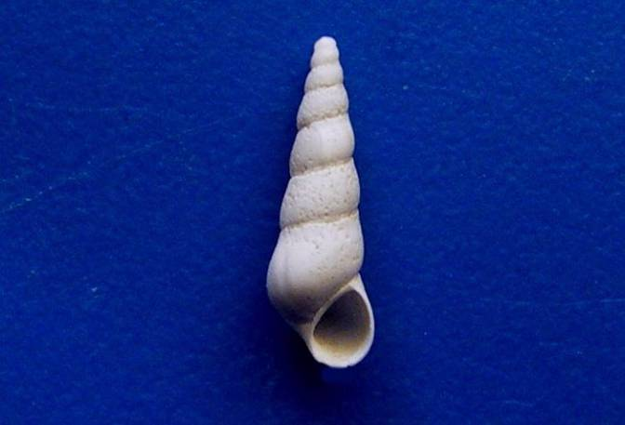 a 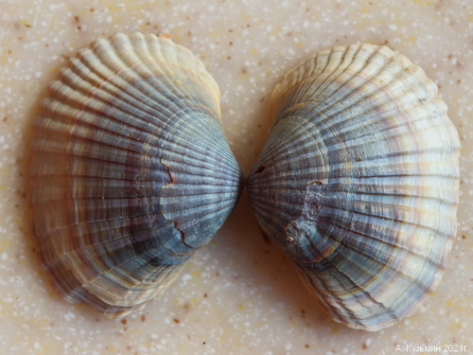b
Figure 15. Mollusks: Euxinipyrgula lincta (a), Euxinipyrgula lincta (b)

Ponto-Caspian mud snail Caspia knipowitchi, which has become rare in its natural habitats, at the same time appeared in new locations in artificial habitats (riverbed of the Southern Bug), which coincides with the reports of foreign colleagues regarding the beginning of its expansion outside Ukraine. A previously unknown mass population of the bivalve Unio crassus was observed in the Orel River channel in July 2021.

